Chapter 9, Solution 63.

First, replace the wye composed of the 20-ohm, 10-ohm, and j15-ohm impedances with the corresponding delta.

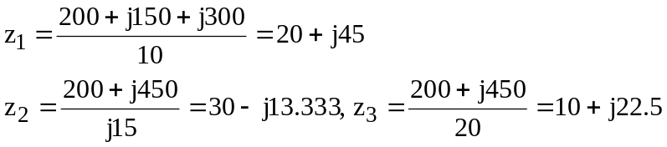

8 Ω
z₁
Z_{T}
–j12 Ω
10 Ω
10 Ω
–j16 Ω
–j16 Ω
z₃
z₂

Now all we need to do is to combine impedances.

